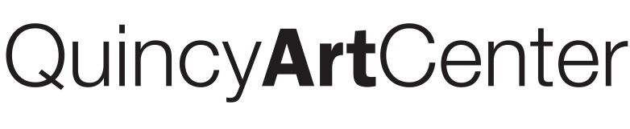
2nd Annual Students and Instructors of the Art Center Exhibit
Friday, January 29 – March 5, 2016
Opening Reception: Friday, January 29 from 7 – 9 pm

Entry Details: The Students and Instructors of the Art Center Exhibit is open to artists who have taken a class or workshop at the Quincy Art Center from March 2015-present. Artists may enter one artwork they have produced in any medium that was made in or inspired by a class, workshop, or program.
Artwork Specifications: All works that are original and have not been previously exhibited at the Art Center will be displayed. All work must be ready to install and wall-hung work must be framed and equipped with hanging devices. When matting, white or off-white mat board is recommended unless the mat is considered part of the piece. Works must fit through a standard double doorway. Maximum dimensions are 6’ for height, width, and depth. The Art Center reserves the right to install works in any manner deemed necessary for exhibition or security reasons and the right to photograph all exhibited works for educational and/or publicity purposes, including our website.
Sales: Sales to the public will be encouraged. The Quincy Art Center will retain a 30% commission.

Work must be hand-delivered to the Art Center and picked up during the following dates and times:
Artwork Delivery: Friday Jan. 15 from 4-6pm and Saturday, Jan. 16 from 9am-4pm
Artwork Pick-Up: Sunday March 6 from 1-4pm and Monday, March 7 from 9am-4pm

Signature ______________________________________________________________
*Information forms received without signature will not be accepted. Your signature indicates acceptance of all conditions listed in this prospectus. Displayed works may not be withdrawn prior to the close of the exhibition.
Artist must complete all information in ink or type. This information is used when creating labels.
Artist Name: Child’s Age: Are you a Member? Yes No If no, please
Include a $5 contribution.
Class/Workshop Title the artwork was made in: Instructor of that class:
Address: Phone:
E-mail:
Artwork Title: Year Completed:
Medium:
Overall Dimensions: Height: Width: Depth (for sculpture only):
Is this artwork for sale? (circle) YES NO
Value: What is the value of the artwork?_________
This value is used as an insurance value. The Quincy Art Center will provide insurance on all works while they are at the Art Center. The QAC cannot insure artwork over $1,500. If the work is for sale, the value will also be used as a sale price. Sale price and insurance value must be the same.
For further information, contact: Quincy Art Center, 1515 Jersey, Quincy, IL 62301
(217) 223-5900 or sstoll@quincyartcenter.org
- - - - - - - - - - - - - - - - - - - - - - - - - - - - - - - - - - - - - - - - - - - - - - - - - - - - - - - - - - - - - - - - - - - - - - - - - - - - - - - - - - - - - -
Please cut here and attach on upper left back of work. The following information must match the information on the above label.
Artist Name: Phone:
Artwork Title: Year Completed:
Medium: Value:
Class/Workshop Title: Instructor:

